Project PortFolio

**Project Structure:**

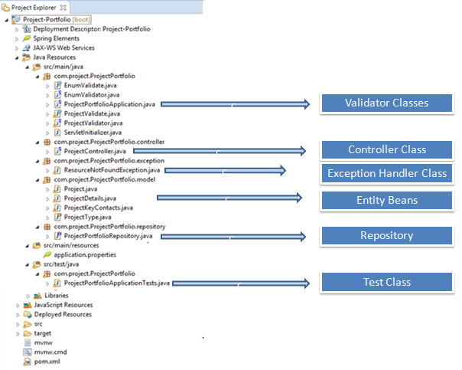

**Scenario 1:** Save Project details with valid data.

URL : http://localhost:8080/project/save

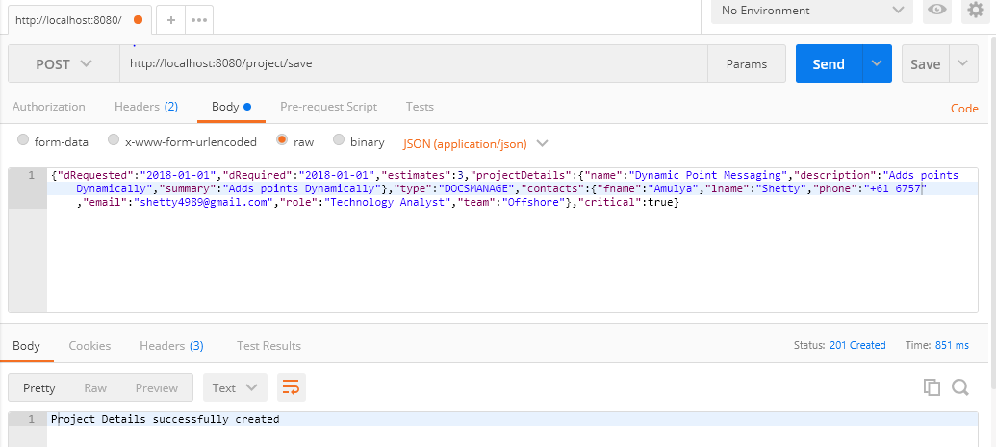

Screen shot of data being saved in DB:

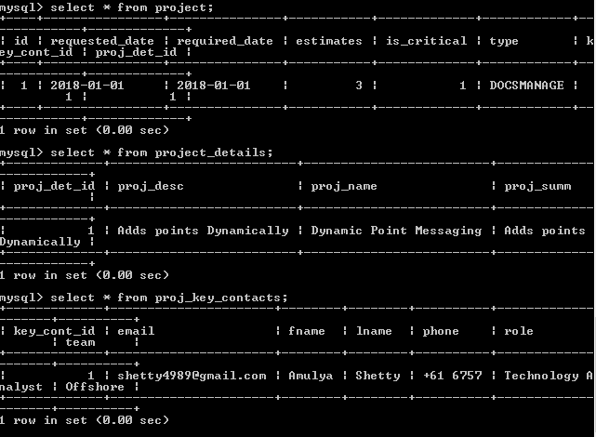

**Scenario 2**: Save Project details with estimates not in between 1 and 21.

URL : http://localhost:8080/project/save

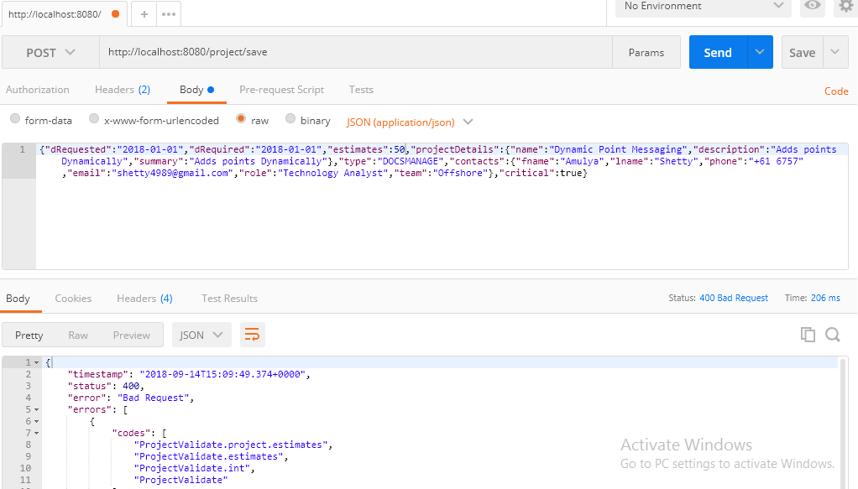

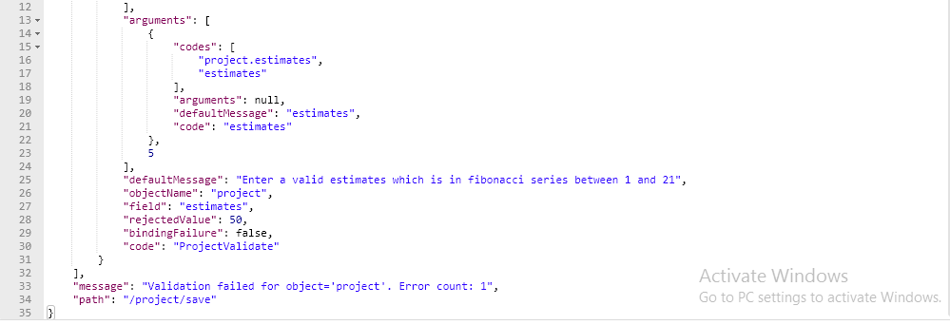

**Scenario 3**: Save project details with estimates not in Fibonacci series

URL : http://localhost:8080/project/save

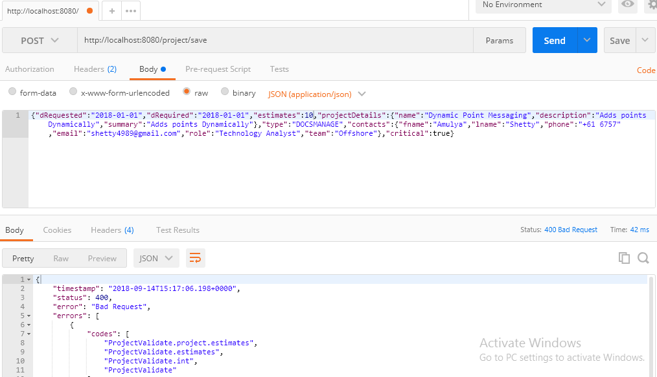

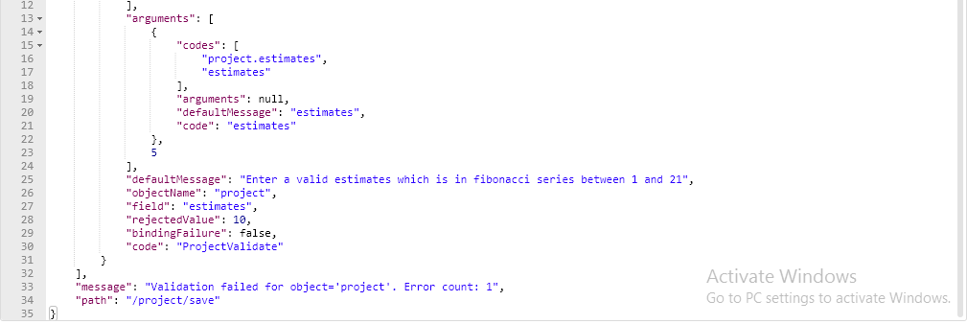

**Scenario 4**: Save Project details with Project Type not in " DOCSMANAGE"

or "SECURITIES"

URL : http://localhost:8080/project/save

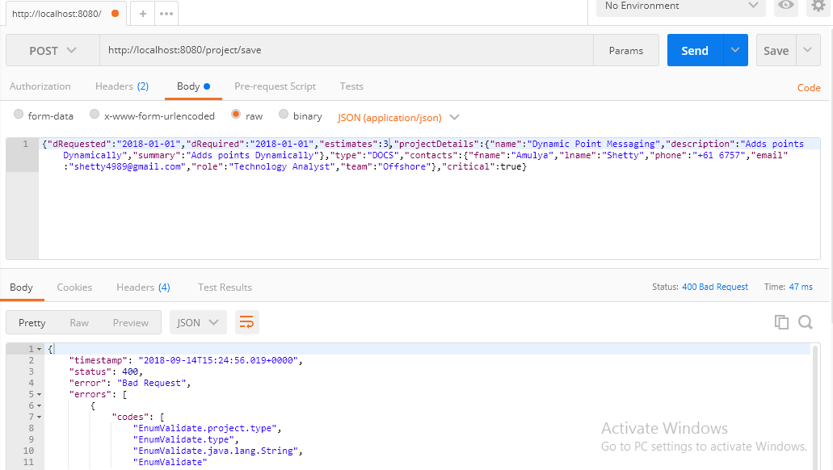

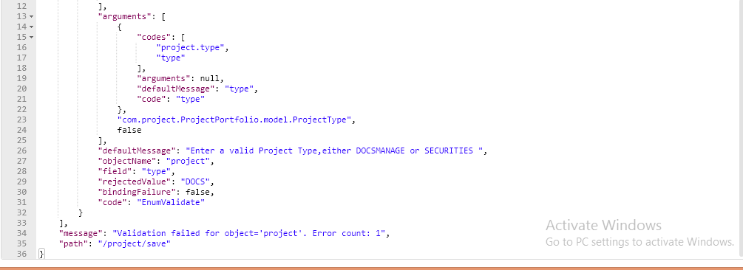

**Scenario 5** : Save Project details with Project Type not in " DOCSMANAGE" or "SECURITIES " as well as estimates not in fibonacci series.

URL : http://localhost:8080/project/save

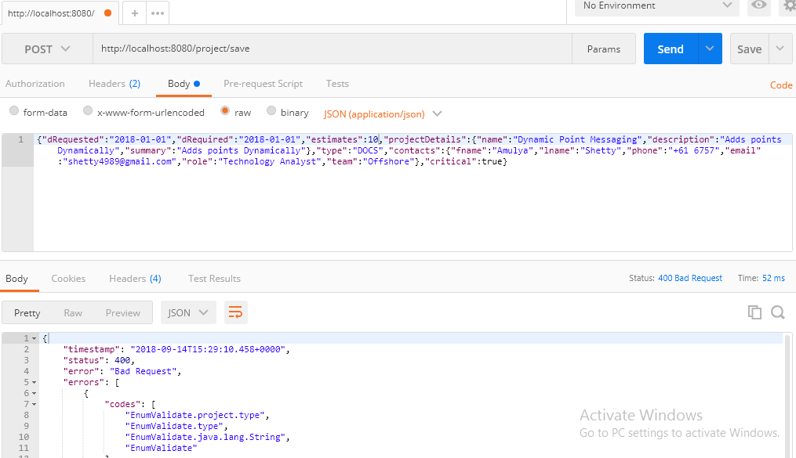

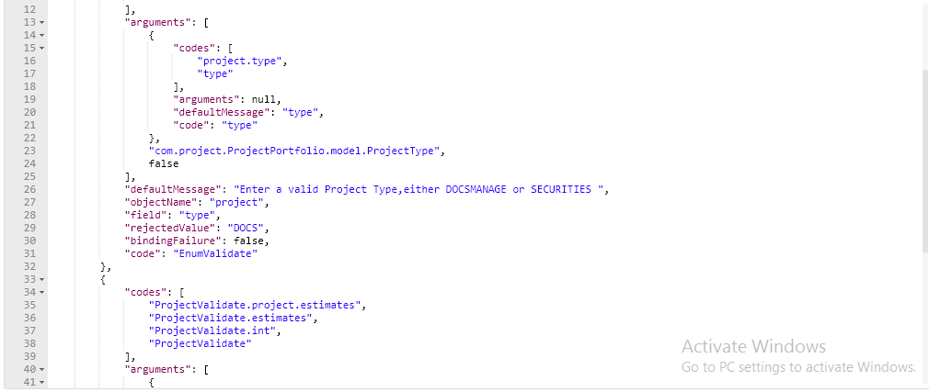

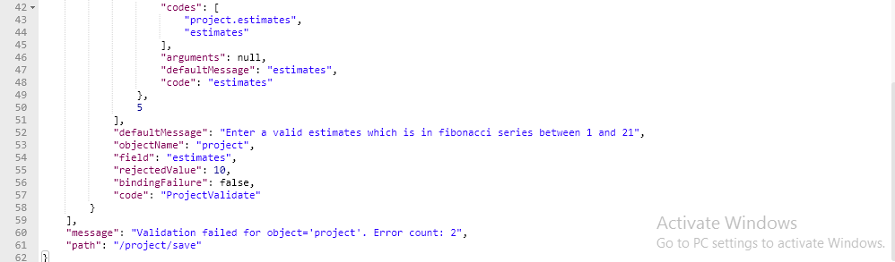

**Scenario 6**: Fetch all project Details

URL: http://localhost:8080/projects

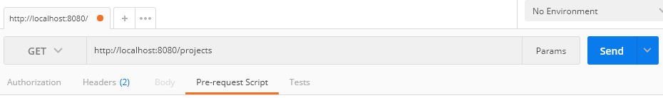

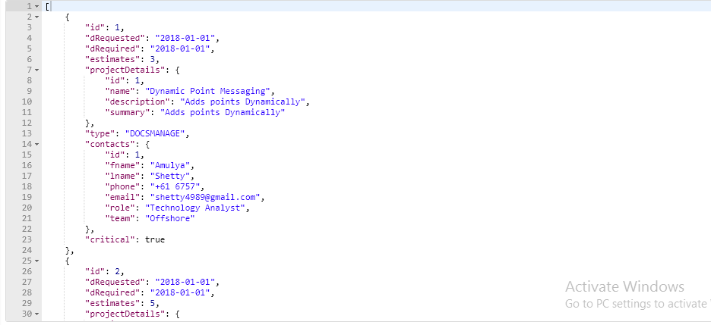 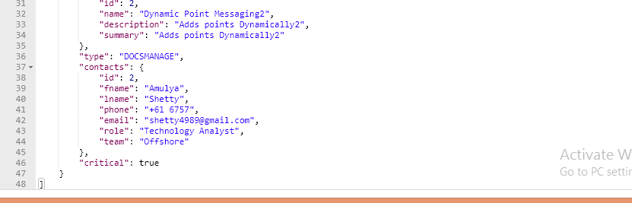

Corresponding DB entries:

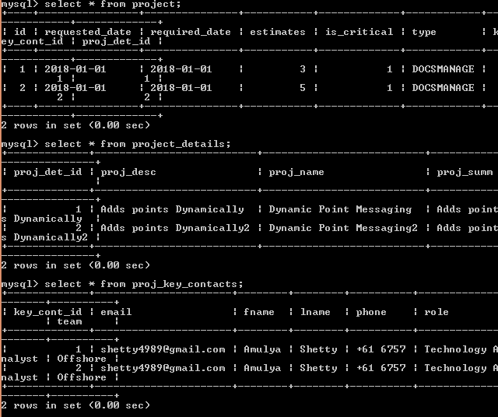

**Scenario 7**: Fetch project by its Id.

URL : http://localhost:8080/projects/2

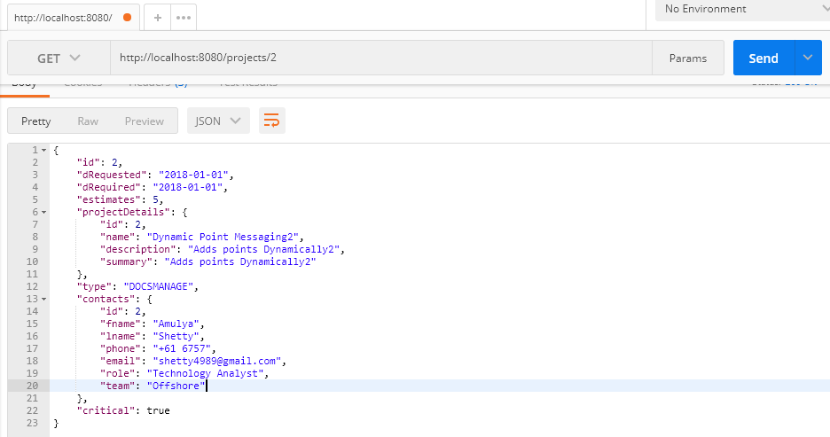

**Scenario 8**: Fetch project by Id that is not found.

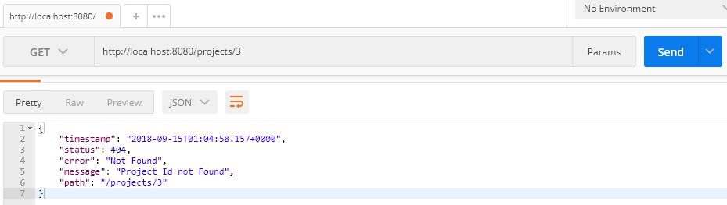

Corresponding DB entries :

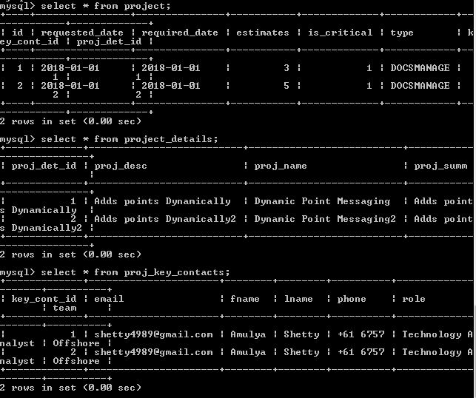

**Scenario 9** : Delete project

URL : http://localhost:8080/projects/2

DB entries before deleting:

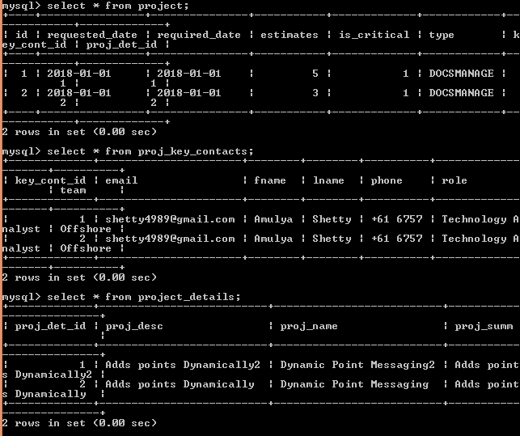

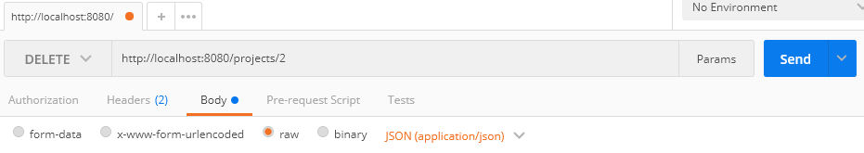

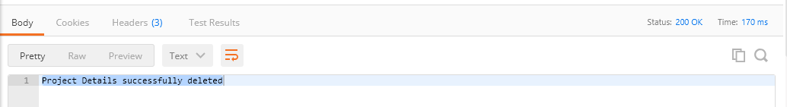

DB entries after deletion:

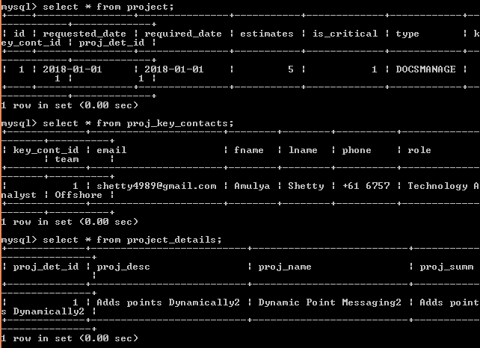

**Scenario 10** : Delete project with an ID that is not found

URL: http://localhost:8080/projects/3

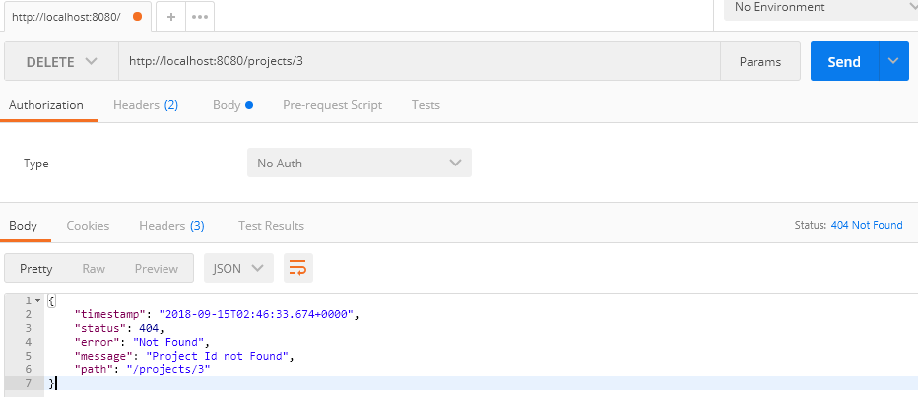

DB entries :



**Scenario 11** : Update Project :Update Parent

URL: http://localhost:8080/projects/1

(ProjectType updated from DOCSMANAGE TO SECURITIES)

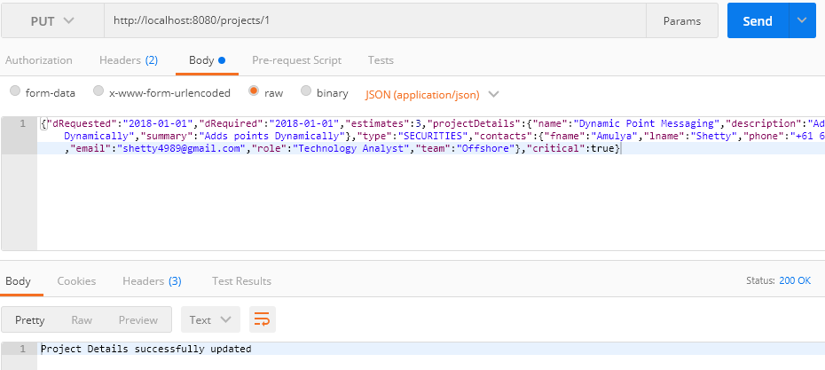

DB entries before updation:

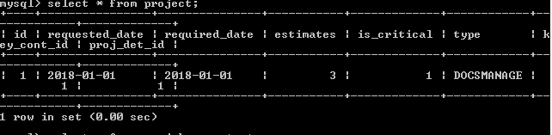

DB entries after updation:

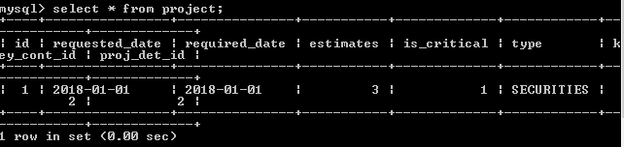

**Scenario 12**: Update Project : Update Child

URL: http://localhost:8080/projects/1

(Project Contacts updated firstname from Amulya to Tejaswi)

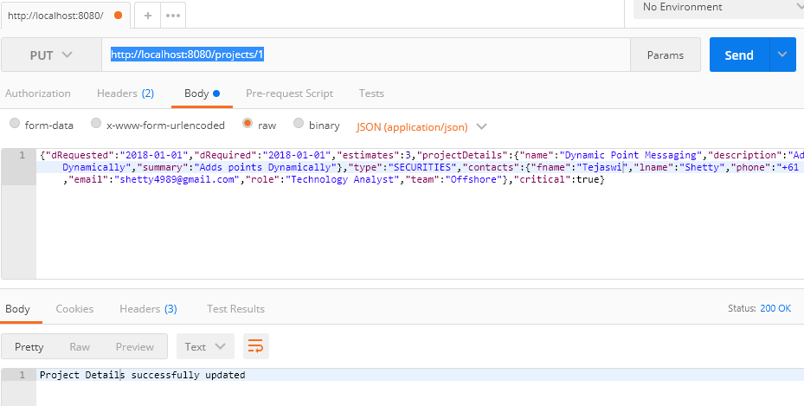

DB entries before updation:

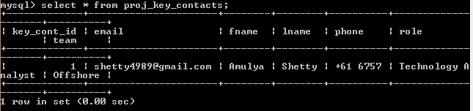

DB entries after updation:

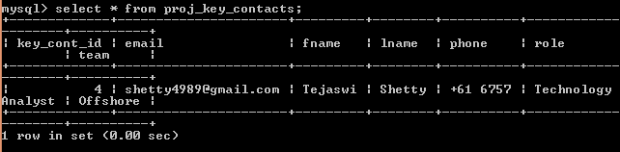

**Scenario 13**: Update Project : Invalid Project ID

http://localhost:8080/projects/3

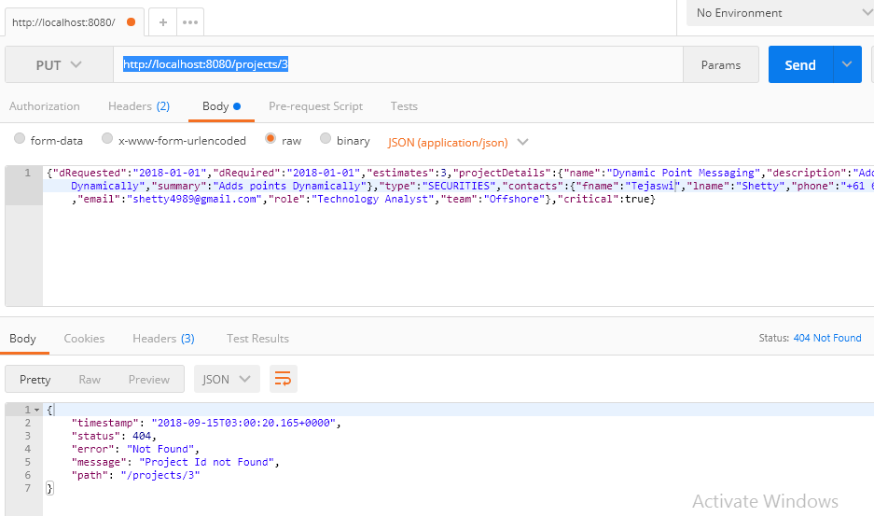

**Scenario 14**: Update Project : Invalid estimates

URL: http://localhost:8080/projects/1

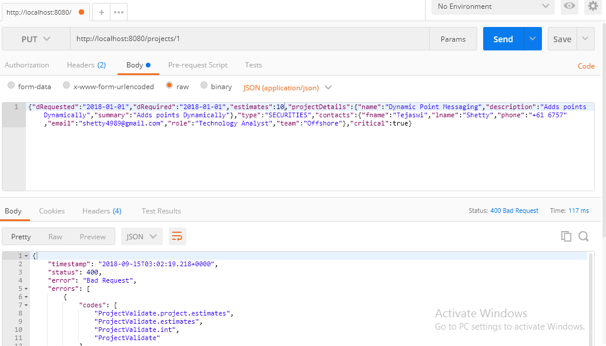

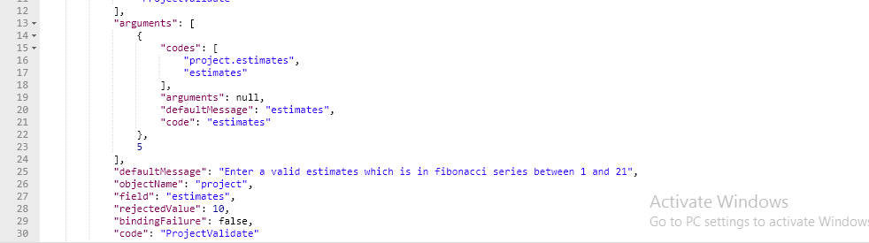

Code Coverage:

